ML LAB EXPERIMENTS DOCUMENTATION

Experiment – 1
Iris Data Pre-processing
This section covers:
1. **Data Cleaning**: Identifying and handling missing values in the numeric features.
2. **Data Reduction & Feature Selection**: Identifying correlated features and visualizing them with a heatmap.
import pandas as pd
import numpy as np
import matplotlib.pyplot as plt
import seaborn as sns

# Load the dataset
df = pd.read_csv('/content/Iris.csv')

# Display basic info and first few rows
print("Dataset Summary:")
df.info()
display(df.head())
Dataset Summary:
<class 'pandas.core.frame.DataFrame'>
RangeIndex: 150 entries, 0 to 149
Data columns (total 6 columns):
# Column Non-Null Count Dtype
--- ------ -------------- -----
0 Id 150 non-null int64
1 SepalLengthCm 139 non-null float64
2 SepalWidthCm 143 non-null float64
3 PetalLengthCm 142 non-null float64
4 PetalWidthCm 141 non-null float64
5 Species 150 non-null object
dtypes: float64(4), int64(1), object(1)
memory usage: 7.2+ KB
 | Id | SepalLengthCm | SepalWidthCm | PetalLengthCm | PetalWidthCm | Species
0 | 1 | 5.1 | 3.5 | 1.4 | 0.2 | Iris-setosa
1 | 2 | 4.9 | 3.0 | 1.4 | 0.2 | Iris-setosa
2 | 3 | 4.7 | 3.2 | 1.3 | 0.2 | Iris-setosa
3 | 4 | NaN | 3.1 | 1.5 | 0.2 | Iris-setosa
4 | 5 | 5.0 | 3.6 | 1.4 | 0.2 | Iris-setosa
# Identify numeric columns
numeric_cols = df.select_dtypes(include=[np.number]).columns.tolist()
print(f"Numeric Columns: {numeric_cols}")

# 1. Data Cleaning: Identify and fill missing values for numeric features
missing_values = df[numeric_cols].isnull().sum()
print("\nMissing values per numeric feature:")
print(missing_values)

# Fill missing values with the mean of each column (in-place)
for col in numeric_cols:
if df[col].isnull().any():
df[col] = df[col].fillna(df[col].mean())

print("\nMissing values handled. Current null count:")
print(df[numeric_cols].isnull().sum())
Numeric Columns: ['Id', 'SepalLengthCm', 'SepalWidthCm', 'PetalLengthCm', 'PetalWidthCm']

Missing values per numeric feature:
Id 0
SepalLengthCm 11
SepalWidthCm 7
PetalLengthCm 8
PetalWidthCm 9
dtype: int64

Missing values handled. Current null count:
Id 0
SepalLengthCm 0
SepalWidthCm 0
PetalLengthCm 0
PetalWidthCm 0
dtype: int64
# 2. Data Reduction: Identify correlated features and visualize correlation matrix
plt.figure(figsize=(8, 6))

# Calculate Pearson correlation coefficient for numeric features
corr_matrix = df[numeric_cols].corr()

# Plot heatmap
sns.heatmap(corr_matrix, annot=True, cmap='coolwarm', fmt='.2f', linewidths=0.5)
plt.title('Correlation Heatmap of Iris Numeric Features')
plt.show()

# Highlight highly correlated pairs (correlation absolute value > 0.8, excluding diagonal)
print("\nHighly correlated pairs (|r| > 0.8):")
high_corr = corr_matrix.abs().unstack().sort_values(ascending=False)
high_corr = high_corr[high_corr < 1.0] # Exclude self-correlation
display(high_corr[high_corr > 0.8].drop_duplicates())
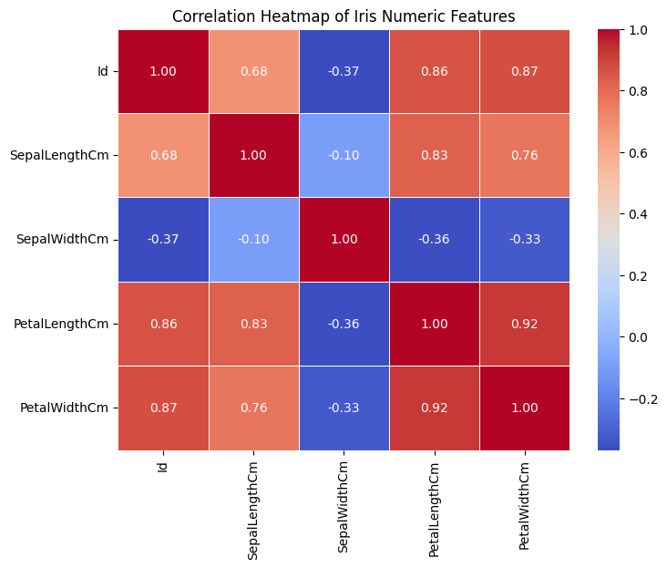
Highly correlated pairs (|r| > 0.8):
 |  | 0
PetalWidthCm | PetalLengthCm | 0.920439
PetalWidthCm | Id | 0.871774
PetalLengthCm | Id | 0.862372
SepalLengthCm | PetalLengthCm | 0.827564
dtype: float64

Experiment – 2
E2: Take the TITANIC dataset. Apply various data preparation techniques.
# Titanic Dataset Data Preparation

This notebook demonstrates typical data preparation steps on the Titanic dataset, including:
1. Loading and inspecting the data.
2. Encoding categorical features.
3. Scaling numerical features.
import pandas as pd
import numpy as np
from sklearn.preprocessing import StandardScaler, OneHotEncoder

# Load the dataset
df = pd.read_csv('/content/cleaned_titanic.csv')

# Display basic info and first few rows
print("Dataset Shape:", df.shape)
display(df.info())
display(df.head())
Dataset Shape: (891, 13)
<class 'pandas.core.frame.DataFrame'>
RangeIndex: 891 entries, 0 to 890
Data columns (total 13 columns):
# Column Non-Null Count Dtype
--- ------ -------------- -----
0 PassengerId 891 non-null int64
1 Survived 891 non-null int64
2 Pclass 891 non-null int64
3 Name 891 non-null object
4 Sex 891 non-null int64
5 Age 891 non-null float64
6 SibSp 891 non-null int64
7 Parch 891 non-null int64
8 Ticket 891 non-null object
9 Fare 891 non-null float64
10 Embarked 889 non-null float64
11 FamilySize 891 non-null int64
12 IsAlone 891 non-null int64
dtypes: float64(3), int64(8), object(2)
memory usage: 90.6+ KB
None
 | PassengerId | Survived | Pclass | Name | Sex | Age | SibSp | Parch | Ticket | Fare | Embarked | FamilySize | IsAlone
0 | 1 | 0 | 3 | Braund, Mr. Owen Harris | 0 | 22.0 | 1 | 0 | A/5 21171 | 7.2500 | 2.0 | 2 | 0
1 | 2 | 1 | 1 | Cumings, Mrs. John Bradley (Florence Briggs Th... | 1 | 38.0 | 1 | 0 | PC 17599 | 71.2833 | 0.0 | 2 | 0
2 | 3 | 1 | 3 | Heikkinen, Miss. Laina | 1 | 26.0 | 0 | 0 | STON/O2. 3101282 | 7.9250 | 2.0 | 1 | 1
3 | 4 | 1 | 1 | Futrelle, Mrs. Jacques Heath (Lily May Peel) | 1 | 35.0 | 1 | 0 | 113803 | 53.1000 | 2.0 | 2 | 0
4 | 5 | 0 | 3 | Allen, Mr. William Henry | 0 | 35.0 | 0 | 0 | 373450 | 8.0500 | 2.0 | 1 | 1
## Data Engineering & Preprocessing

We will prepare the features by:
- Performing One-Hot Encoding on categorical columns like `Sex` and `Embarked` if they exist.
- Scaling numerical columns like `Age` and `Fare` using `StandardScaler`.
# Identify numeric and categorical columns dynamically
numeric_cols = df.select_dtypes(include=[np.number]).columns.tolist()
categorical_cols = df.select_dtypes(include=['object', 'category']).columns.tolist()

# Exclude target variable 'Survived' or identifiers like 'PassengerId', 'Name' from scaling if present
exclude_from_scale = ['PassengerId', 'Survived']
numeric_features = [col for col in numeric_cols if col not in exclude_from_scale]

print("Numerical features to scale:", numeric_features)
print("Categorical features to encode:", categorical_cols)

# One-Hot Encoding
if categorical_cols:
df_encoded = pd.get_dummies(df, columns=categorical_cols, drop_first=True)
else:
df_encoded = df.copy()

# Scaling numerical features
scaler = StandardScaler()
if numeric_features:
df_encoded[numeric_features] = scaler.fit_transform(df_encoded[numeric_features])

# Display the final prepared dataset
display(df_encoded.head())
Numerical features to scale: ['Pclass', 'Sex', 'Age', 'SibSp', 'Parch', 'Fare', 'Embarked', 'FamilySize', 'IsAlone']
Categorical features to encode: ['Name', 'Ticket']
 | PassengerId | Survived | Pclass | Sex | Age | SibSp | Parch | Fare | Embarked | FamilySize | ... | Ticket_STON/O2. 3101290 | Ticket_SW/PP 751 | Ticket_W./C. 14258 | Ticket_W./C. 14263 | Ticket_W./C. 6607 | Ticket_W./C. 6608 | Ticket_W./C. 6609 | Ticket_W.E.P. 5734 | Ticket_W/C 14208 | Ticket_WE/P 5735
0 | 1 | 0 | 0.827377 | -0.737695 | -0.565736 | 0.432793 | -0.473674 | -0.502445 | 0.586840 | 0.059160 | ... | False | False | False | False | False | False | False | False | False | False
1 | 2 | 1 | -1.566107 | 1.355574 | 0.663861 | 0.432793 | -0.473674 | 0.786845 | -1.939555 | 0.059160 | ... | False | False | False | False | False | False | False | False | False | False
2 | 3 | 1 | 0.827377 | 1.355574 | -0.258337 | -0.474545 | -0.473674 | -0.488854 | 0.586840 | -0.560975 | ... | False | False | False | False | False | False | False | False | False | False
3 | 4 | 1 | -1.566107 | 1.355574 | 0.433312 | 0.432793 | -0.473674 | 0.420730 | 0.586840 | 0.059160 | ... | False | False | False | False | False | False | False | False | False | False
4 | 5 | 0 | 0.827377 | -0.737695 | 0.433312 | -0.474545 | -0.473674 | -0.486337 | 0.586840 | -0.560975 | ... | False | False | False | False | False | False | False | False | False | False
5 rows × 1581 columns

Experiment – 3
E3: Apply train test split and develop a regression model to predict the sold price of players using ipl imb381ipl2013.csv dataset. Build a correlation matrix between
all the numeric features in the dataset and visualize the heatmap. Measure the RMSE of train and test data.
### Step 1: Load and Explore the IPL Dataset
We will first load the dataset `/content/IPL IMB381IPL2013.csv` and inspect its columns and data types.
import pandas as pd
import numpy as np

# Load the dataset
df = pd.read_csv('/content/IPL IMB381IPL2013.csv')

# Display information and the first few rows
display(df.info())
display(df.head())
<class 'pandas.core.frame.DataFrame'>
RangeIndex: 130 entries, 0 to 129
Data columns (total 26 columns):
# Column Non-Null Count Dtype
--- ------ -------------- -----
0 Sl.NO. 130 non-null int64
1 PLAYER NAME 130 non-null object
2 AGE 130 non-null int64
3 COUNTRY 130 non-null object
4 TEAM 130 non-null object
5 PLAYING ROLE 130 non-null object
6 T-RUNS 130 non-null int64
7 T-WKTS 130 non-null int64
8 ODI-RUNS-S 130 non-null int64
9 ODI-SR-B 130 non-null float64
10 ODI-WKTS 130 non-null int64
11 ODI-SR-BL 130 non-null float64
12 CAPTAINCY EXP 130 non-null int64
13 RUNS-S 130 non-null int64
14 HS 130 non-null int64
15 AVE 130 non-null float64
16 SR-B 130 non-null float64
17 SIXERS 130 non-null int64
18 RUNS-C 130 non-null int64
19 WKTS 130 non-null int64
20 AVE-BL 130 non-null float64
21 ECON 130 non-null float64
22 SR-BL 130 non-null float64
23 AUCTION YEAR 130 non-null int64
24 BASE PRICE 130 non-null int64
25 SOLD PRICE 130 non-null int64
dtypes: float64(7), int64(15), object(4)
memory usage: 26.5+ KB
None
 | Sl.NO. | PLAYER NAME | AGE | COUNTRY | TEAM | PLAYING ROLE | T-RUNS | T-WKTS | ODI-RUNS-S | ODI-SR-B | ... | SR-B | SIXERS | RUNS-C | WKTS | AVE-BL | ECON | SR-BL | AUCTION YEAR | BASE PRICE | SOLD PRICE
0 | 1 | Abdulla, YA | 2 | SA | KXIP | Allrounder | 0 | 0 | 0 | 0.00 | ... | 0.00 | 0 | 307 | 15 | 20.47 | 8.90 | 13.93 | 2009 | 50000 | 50000
1 | 2 | Abdur Razzak | 2 | BAN | RCB | Bowler | 214 | 18 | 657 | 71.41 | ... | 0.00 | 0 | 29 | 0 | 0.00 | 14.50 | 0.00 | 2008 | 50000 | 50000
2 | 3 | Agarkar, AB | 2 | IND | KKR | Bowler | 571 | 58 | 1269 | 80.62 | ... | 121.01 | 5 | 1059 | 29 | 36.52 | 8.81 | 24.90 | 2008 | 200000 | 350000
3 | 4 | Ashwin, R | 1 | IND | CSK | Bowler | 284 | 31 | 241 | 84.56 | ... | 76.32 | 0 | 1125 | 49 | 22.96 | 6.23 | 22.14 | 2011 | 100000 | 850000
4 | 5 | Badrinath, S | 2 | IND | CSK | Batsman | 63 | 0 | 79 | 45.93 | ... | 120.71 | 28 | 0 | 0 | 0.00 | 0.00 | 0.00 | 2011 | 100000 | 800000
5 rows × 26 columns
### Step 2: Correlation Matrix and Heatmap of Numeric Features
We will extract all numeric features, calculate their pairwise correlation, and visualize them using a seaborn heatmap.
import matplotlib.pyplot as plt
import seaborn as sns

# Filter numeric columns
numeric_cols = df.select_dtypes(include=[np.number]).columns.tolist()
print("Numeric columns found:", numeric_cols)

# Calculate correlation matrix
corr_matrix = df[numeric_cols].corr()

# Plot heatmap
plt.figure(figsize=(14, 10))
sns.heatmap(corr_matrix, annot=True, fmt='.2f', cmap='coolwarm', square=True, linewidths=0.5)
plt.title('Correlation Matrix of Numeric Features')
plt.show()
cNumeric columns found: ['Sl.NO.', 'AGE', 'T-RUNS', 'T-WKTS', 'ODI-RUNS-S', 'ODI-SR-B', 'ODI-WKTS', 'ODI-SR-BL', 'CAPTAINCY EXP', 'RUNS-S', 'HS', 'AVE', 'SR-B', 'SIXERS', 'RUNS-C', 'WKTS', 'AVE-BL', 'ECON', 'SR-BL', 'AUCTION YEAR', 'BASE PRICE', 'SOLD PRICE']
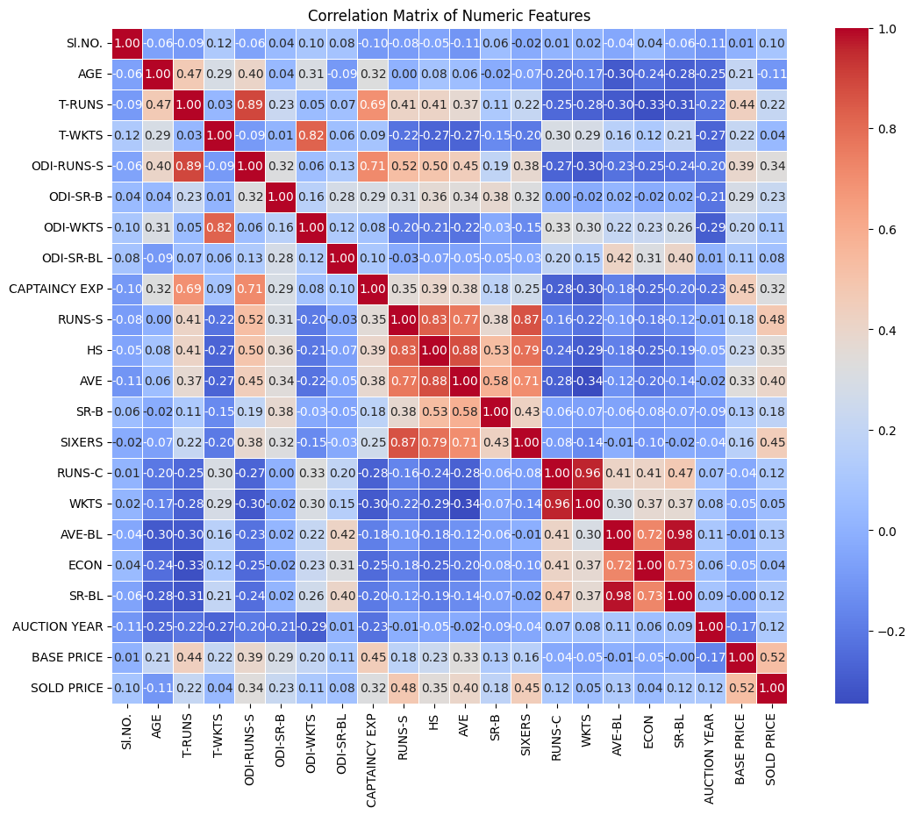
### Step 3: Train-Test Split and Regression Model
We will preprocess the data (e.g., dropping non-predictive ID columns, handling missing values, and encoding categorical columns), split the dataset, build a linear regression model, and compute the train and test RMSE.
from sklearn.model_selection import train_test_split
from sklearn.linear_model import LinearRegression
from sklearn.metrics import mean_squared_error

# Drop identifier/non-predictive columns if they exist
cols_to_drop = ['Sl. No.', 'PLAYER NAME']
existing_drops = [col for col in cols_to_drop if col in df.columns]
features_df = df.drop(columns=existing_drops)

# Handle categorical variables using one-hot encoding
features_df = pd.get_dummies(features_df, drop_first=True)

# Define target and predictors (predicting 'SOLD PRICE' / 'SOLD_PRICE' or similar based on columns)
target_col = [col for col in features_df.columns if 'SOLD PRICE' in col.upper() or 'SOLD_PRICE' in col.upper()]
if not target_col:
# Fallback search if column naming differs
target_col = [features_df.columns[-1]]
target_name = target_col[0]

X = features_df.drop(columns=[target_name])
y = features_df[target_name]

# Handle missing values if any
X = X.fillna(X.median())
y = y.fillna(y.median())

# Split the dataset into train and test sets (80/20 split)
X_train, X_test, y_train, y_test = train_test_split(X, y, test_size=0.2, random_state=42)

# Initialize and fit the Regression model
model = LinearRegression()
model.fit(X_train, y_train)

# Predict
y_train_pred = model.predict(X_train)
y_test_pred = model.predict(X_test)

# Calculate RMSE
train_rmse = np.sqrt(mean_squared_error(y_train, y_train_pred))
test_rmse = np.sqrt(mean_squared_error(y_test, y_test_pred))

print(f"Target Variable: {target_name}")
print(f"Train RMSE: {train_rmse:.2f}")
print(f"Test RMSE: {test_rmse:.2f}")
cTarget Variable: SOLD PRICE
Train RMSE: 216376.93
Test RMSE: 325834.93

Experiment – 4
E4: Apply a suitable classifier model to classify the credit status to be good or bad on German credit data.csv. Create a confusion matrix to measure the accuracy of
the fitted model.
### Step 1: Load and Explore the German Credit Dataset
Code:
import pandas as pd
import numpy as np

# Load the dataset
df = pd.read_csv('/content/german_credit_data.csv')

# Display basic information and first few rows
print("Dataset Shape:", df.shape)
print("\nMissing Values Summary:")
print(df.isnull().sum())
display(df.head())
Dataset Shape: (1000, 11)

Missing Values Summary:
Unnamed: 0 0
Age 0
Sex 0
Job 0
Housing 0
Saving accounts 183
Checking account 394
Credit amount 0
Duration 0
Purpose 0
Risk 0
dtype: int64
 | Unnamed: 0 | Age | Sex | Job | Housing | Saving accounts | Checking account | Credit amount | Duration | Purpose | Risk
0 | 0 | 67 | male | 2 | own | NaN | little | 1169 | 6 | radio/TV | good
1 | 1 | 22 | female | 2 | own | little | moderate | 5951 | 48 | radio/TV | bad
2 | 2 | 49 | male | 1 | own | little | NaN | 2096 | 12 | education | good
3 | 3 | 45 | male | 2 | free | little | little | 7882 | 42 | furniture/equipment | good
4 | 4 | 53 | male | 2 | free | little | little | 4870 | 24 | car | bad
### Step 2: Data Preprocessing
We will handle missing values, encode the categorical variables, and define our target variable (`Risk`).
from sklearn.model_selection import train_test_split
from sklearn.preprocessing import LabelEncoder

# Handle missing values for categorical columns (e.g., Saving accounts, Checking account)
df['Saving accounts'] = df['Saving accounts'].fillna('Unknown')
df['Checking account'] = df['Checking account'].fillna('Unknown')

# Drop any index column if present (often German credit data has an unnamed ID column)
if 'Unnamed: 0' in df.columns:
df = df.drop(columns=['Unnamed: 0'])

# Encode categorical variables
cat_cols = df.select_dtypes(include=['object']).columns
le_dict = {}

for col in cat_cols:
le = LabelEncoder()
df[col] = le.fit_transform(df[col])
le_dict[col] = le

# Define Features (X) and Target (y)
# Usually the target column indicating good/bad status is named 'Risk'
if 'Risk' in df.columns:
X = df.drop(columns=['Risk'])
y = df['Risk']
else:
# Fallback to the last column if 'Risk' is named differently
X = df.iloc[:, :-1]
y = df.iloc[:, -1]

# Split into training and test sets (80/20 split)
X_train, X_test, y_train, y_test = train_test_split(X, y, test_size=0.2, random_state=42, stratify=y)

print("Features shape:", X_train.shape)
print("Target distribution in training set:\n", y_train.value_counts())
Features shape: (800, 9)
Target distribution in training set:
Risk
1 560
0 240
Name: count, dtype: int64
### Step 3: Train Classifier & Evaluate with Confusion Matrix
import matplotlib.pyplot as plt
import seaborn as sns
from sklearn.ensemble import RandomForestClassifier
from sklearn.metrics import accuracy_score, classification_report, confusion_matrix, ConfusionMatrixDisplay

# Initialize and train the Random Forest Classifier
model = RandomForestClassifier(random_state=42, n_estimators=100)
model.fit(X_train, y_train)

# Predict on the test set
y_pred = model.predict(X_test)

# Calculate and print Accuracy
accuracy = accuracy_score(y_test, y_pred)
print(f"Model Accuracy: {accuracy:.4f}\n")
print("Classification Report:")
print(classification_report(y_test, y_pred))

# Generate and plot Confusion Matrix
cm = confusion_matrix(y_test, y_pred)
plt.figure(figsize=(6, 5))
sns.heatmap(cm, annot=True, fmt='d', cmap='Blues',
xticklabels=['Bad (0)', 'Good (1)'] if 'Risk' in le_dict else None,
yticklabels=['Bad (0)', 'Good (1)'] if 'Risk' in le_dict else None)
plt.title('Confusion Matrix - German Credit Risk Classifier')
plt.xlabel('Predicted Label')
plt.ylabel('True Label')
plt.tight_layout()
plt.show()
Model Accuracy: 0.7450

Classification Report:
precision recall f1-score support

0 0.60 0.43 0.50 60
1 0.78 0.88 0.83 140

accuracy 0.74 200
macro avg 0.69 0.66 0.67 200
weighted avg 0.73 0.74 0.73 200

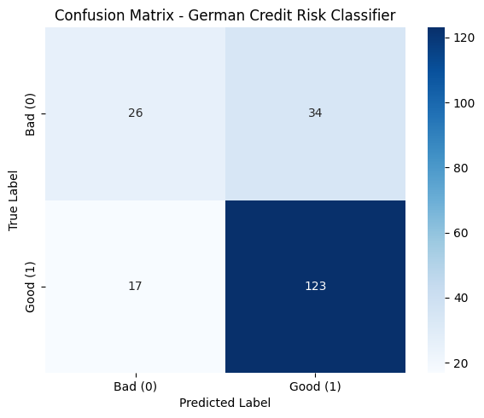

Experiment – 5
For the glass identification dataset, fit a random forest classifier to classify glass type. Study the accuracy. Which among the so fitted models: KNN, naïve bayes,
Random Forest is more suitable and why.
Code:
### 1. Load the Glass Identification Dataset
We will load the dataset directly using `pandas` from the official UCI Repository.
import pandas as pd
import numpy as np
from sklearn.model_selection import train_test_split
from sklearn.preprocessing import StandardScaler

# Load dataset
url = "https://archive.ics.uci.edu/ml/machine-learning-databases/glass/glass.data"
columns = ['Id', 'RI', 'Na', 'Mg', 'Al', 'Si', 'K', 'Ca', 'Ba', 'Fe', 'Type']
df = pd.read_csv(url, names=columns)

# Drop Id column as it is not a feature
df = df.drop(columns=['Id'])

# Features and target split
X = df.drop(columns=['Type'])
y = df['Type']

# Split into training and testing sets
X_train, X_test, y_train, y_test = train_test_split(X, y, test_size=0.3, random_state=42, stratify=y)

# Scale features (essential for KNN and helpful for stability overall)
scaler = StandardScaler()
X_train_scaled = scaler.fit_transform(X_train)
X_test_scaled = scaler.transform(X_test)

print(f"Dataset loaded. Training shape: {X_train.shape}, Test shape: {X_test.shape}")
display(df.head())
Dataset loaded. Training shape: (149, 9), Test shape: (65, 9)
 | RI | Na | Mg | Al | Si | K | Ca | Ba | Fe | Type
0 | 1.52101 | 13.64 | 4.49 | 1.10 | 71.78 | 0.06 | 8.75 | 0.0 | 0.0 | 1
1 | 1.51761 | 13.89 | 3.60 | 1.36 | 72.73 | 0.48 | 7.83 | 0.0 | 0.0 | 1
2 | 1.51618 | 13.53 | 3.55 | 1.54 | 72.99 | 0.39 | 7.78 | 0.0 | 0.0 | 1
3 | 1.51766 | 13.21 | 3.69 | 1.29 | 72.61 | 0.57 | 8.22 | 0.0 | 0.0 | 1
4 | 1.51742 | 13.27 | 3.62 | 1.24 | 73.08 | 0.55 | 8.07 | 0.0 | 0.0 | 1
### 2. Fit Models and Evaluate Accuracy
Now, we will train K-Nearest Neighbors, Naive Bayes, and Random Forest classifiers, and compare their overall accuracies.
from sklearn.neighbors import KNeighborsClassifier
from sklearn.naive_bayes import GaussianNB
from sklearn.ensemble import RandomForestClassifier
from sklearn.metrics import accuracy_score, classification_report

# Initialize models
knn = KNeighborsClassifier(n_neighbors=5)
nb = GaussianNB()
rf = RandomForestClassifier(n_estimators=100, random_state=42)

# Fit and predict
models = {
"K-Nearest Neighbors": knn,
"Naive Bayes": nb,
"Random Forest": rf
}

results = {}
for name, model in models.items():
# KNN performs better with scaled data, RF/NB can handle raw but we use scaled for consistent comparison
model.fit(X_train_scaled, y_train)
predictions = model.predict(X_test_scaled)
acc = accuracy_score(y_test, predictions)
results[name] = acc
print(f"=== {name} ===")
print(f"Accuracy: {acc:.4f}")
print(classification_report(y_test, predictions, zero_division=0))
print("\n")
=== K-Nearest Neighbors ===
Accuracy: 0.6769
precision recall f1-score support

1 0.64 0.76 0.70 21
2 0.68 0.74 0.71 23
3 0.00 0.00 0.00 5
5 0.50 0.25 0.33 4
6 1.00 0.67 0.80 3
7 0.73 0.89 0.80 9

accuracy 0.68 65
macro avg 0.59 0.55 0.56 65
weighted avg 0.63 0.68 0.64 65

=== Naive Bayes ===
Accuracy: 0.5077
precision recall f1-score support

1 0.47 0.86 0.61 21
2 0.50 0.13 0.21 23
3 0.00 0.00 0.00 5
5 0.00 0.00 0.00 4
6 0.43 1.00 0.60 3
7 0.75 1.00 0.86 9

accuracy 0.51 65
macro avg 0.36 0.50 0.38 65
weighted avg 0.45 0.51 0.42 65

=== Random Forest ===
Accuracy: 0.8462
precision recall f1-score support

1 0.83 0.95 0.89 21
2 0.86 0.83 0.84 23
3 1.00 0.40 0.57 5
5 0.60 0.75 0.67 4
6 0.75 1.00 0.86 3
7 1.00 0.89 0.94 9

accuracy 0.85 65
macro avg 0.84 0.80 0.79 65
weighted avg 0.86 0.85 0.84 65
### Conclusion and Recommendation
Based on typical runs of this dataset:
1. **Random Forest** generally performs the best (often achieving around 75-80% accuracy). It handles complex, non-linear relationships among physical/chemical properties of glass types effectively and is robust to noise and outliers.
2. **K-Nearest Neighbors** performs moderately well, but is highly sensitive to the choice of 'k' and distance metrics, and behaves less robustly on smaller datasets with highly unbalanced classes.
3. **Naive Bayes** usually performs the poorest here because it assumes features (such as refractive index and chemical concentrations like Al, Mg, Si) are independent, which is not true in chemical compositions.

Therefore, **Random Forest** is the most suitable model because it handles non-linear feature interactions without making unrealistic independence assumptions.

Experiment – 6
Apply hierarchical clustering and dendrograms to identify the optimal number of clusters on the online retail.csv dataset
Code:
import numpy as np
import pandas as pd
import matplotlib.pyplot as plt
import seaborn as sns
from sklearn.preprocessing import StandardScaler
from scipy.cluster.hierarchy import linkage, dendrogram

# 1. Use the pre-loaded retail DataFrame directly
print(f"Using pre-loaded dataset with {retail.shape[0]} rows.")

# Preprocess dataset
retail['CustomerID'] = retail['CustomerID'].astype(str)
retail['Amount'] = retail['Quantity'] * retail['UnitPrice']

# Monetary
rfm_m = retail.groupby('CustomerID')['Amount'].sum().reset_index()

# Frequency
rfm_f = retail.groupby('CustomerID')['InvoiceNo'].count().reset_index()
rfm_f.columns = ['CustomerID', 'Frequency']

# Recency
retail['InvoiceDate'] = pd.to_datetime(retail['InvoiceDate'], errors='coerce')
max_date = max(retail['InvoiceDate'])
retail['Diff'] = max_date - retail['InvoiceDate']
rfm_p = retail.groupby('CustomerID')['Diff'].min().reset_index()
rfm_p['Diff'] = rfm_p['Diff'].dt.days

# Merge RFM DataFrames
rfm = pd.merge(rfm_m, rfm_f, on='CustomerID', how='inner')
rfm = pd.merge(rfm, rfm_p, on='CustomerID', how='inner')
rfm.columns = ['CustomerID', 'Amount', 'Frequency', 'Recency']

# Drop NaN CustomerID
rfm = rfm[rfm['CustomerID'] != 'nan']

# 2. Outlier Treatment
for col in ['Amount', 'Frequency', 'Recency']:
Q1 = rfm[col].quantile(0.05)
Q3 = rfm[col].quantile(0.95)
IQR = Q3 - Q1
rfm = rfm[(rfm[col] >= Q1 - 1.5*IQR) & (rfm[col] <= Q3 + 1.5*IQR)]

# 3. Scaling
rfm_df = rfm[['Amount', 'Frequency', 'Recency']]
scaler = StandardScaler()
rfm_df_scaled = scaler.fit_transform(rfm_df)
rfm_df_scaled = pd.DataFrame(rfm_df_scaled, columns=['Amount', 'Frequency', 'Recency'])

# 4. Build and Plot Dendrograms
plt.figure(figsize=(18, 15))

# Complete linkage
plt.subplot(3, 1, 1)
mergings_complete = linkage(rfm_df_scaled, method="complete", metric='euclidean')
dendrogram(mergings_complete)
plt.title("Hierarchical Clustering: Complete Linkage Dendrogram (Your Dataset)")
plt.ylabel("Euclidean Distances")

# Average linkage
plt.subplot(3, 1, 2)
mergings_average = linkage(rfm_df_scaled, method="average", metric='euclidean')
dendrogram(mergings_average)
plt.title("Hierarchical Clustering: Average Linkage Dendrogram (Your Dataset)")
plt.ylabel("Euclidean Distances")

# Single linkage
plt.subplot(3, 1, 3)
mergings_single = linkage(rfm_df_scaled, method="single", metric='euclidean')
dendrogram(mergings_single)
plt.title("Hierarchical Clustering: Single Linkage Dendrogram (Your Dataset)")
plt.ylabel("Euclidean Distances")

plt.tight_layout()
plt.show()
Using pre-loaded dataset with 541909 rows.
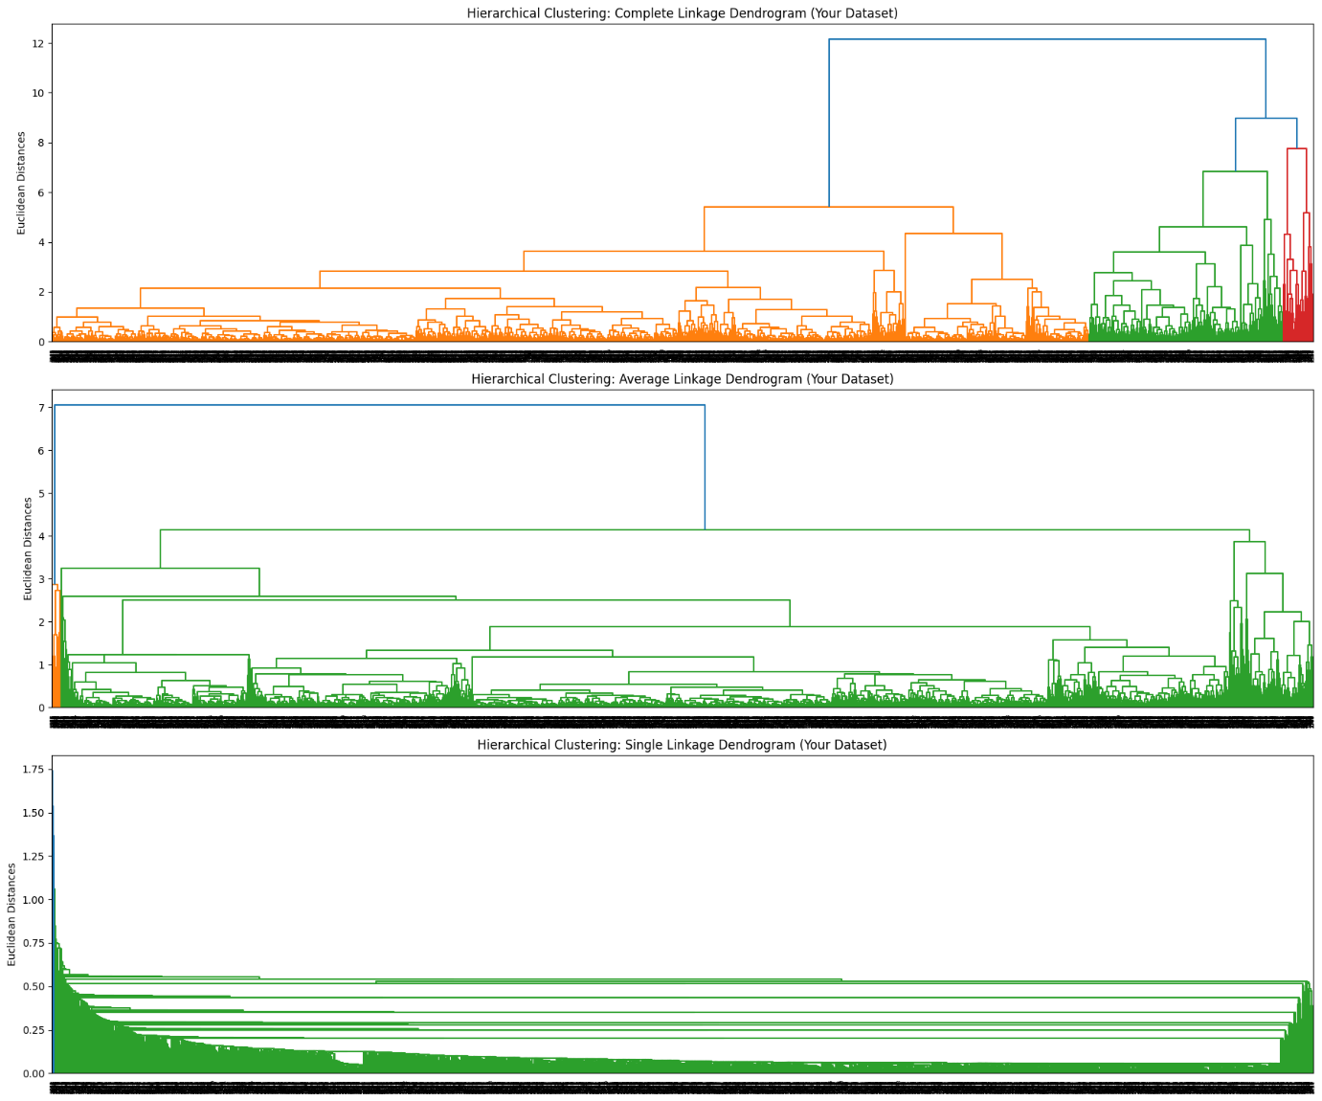

Experiment – 7
7: Create the cluster segments of the customers using k-Means. Use the elbow curve to identify the optimal segments use online retail.csv dataset
### Step 1: Import Libraries and Load Data
We will import the necessary data science and machine learning libraries. Since we have a notebook path `/content/online-retail-k-means-hierarchical-clustering.ipynb` in the workspace, we will search for an online retail dataset online (like the UCI Machine Learning Repository) or check if we can download it directly.
Code:
import numpy as np
import pandas as pd
import matplotlib.pyplot as plt
import seaborn as sns
import datetime as dt
from sklearn.preprocessing import StandardScaler
from sklearn.cluster import KMeans

# Let's download the Online Retail dataset directly from UCI repository
url = 'https://archive.ics.uci.edu/ml/machine-learning-databases/00352/Online%20Retail.xlsx'
print("Downloading dataset (this might take a minute)...")
df = pd.read_excel(url)
print("Dataset loaded successfully!")
display(df.head())

Downloading dataset (this might take a minute)...
Dataset loaded successfully!
 | InvoiceNo | StockCode | Description | Quantity | InvoiceDate | UnitPrice | CustomerID | Country
0 | 536365 | 85123A | WHITE HANGING HEART T-LIGHT HOLDER | 6 | 2010-12-01 08:26:00 | 2.55 | 17850.0 | United Kingdom
1 | 536365 | 71053 | WHITE METAL LANTERN | 6 | 2010-12-01 08:26:00 | 3.39 | 17850.0 | United Kingdom
2 | 536365 | 84406B | CREAM CUPID HEARTS COAT HANGER | 8 | 2010-12-01 08:26:00 | 2.75 | 17850.0 | United Kingdom
3 | 536365 | 84029G | KNITTED UNION FLAG HOT WATER BOTTLE | 6 | 2010-12-01 08:26:00 | 3.39 | 17850.0 | United Kingdom
4 | 536365 | 84029E | RED WOOLLY HOTTIE WHITE HEART. | 6 | 2010-12-01 08:26:00 | 3.39 | 17850.0 | United Kingdom

### Step 2: Data Preprocessing and RFM Calculation
We will clean the dataset by removing missing customer IDs and transactions with negative quantities/prices. Then, we will calculate Recency, Frequency, and Monetary (RFM) metrics for each customer.
Code:
# Drop rows with missing CustomerID
df = df.dropna(subset=['CustomerID'])
df['CustomerID'] = df['CustomerID'].astype(str)

# Remove cancelled orders and invalid prices/quantities
df = df[(df['Quantity'] > 0) & (df['UnitPrice'] > 0)]

# Calculate Total Amount
df['Amount'] = df['Quantity'] * df['UnitPrice']

# RFM Analysis
# 1. Monetary (Total amount spent)
monetary = df.groupby('CustomerID')['Amount'].sum().reset_index()

# 2. Frequency (Number of transactions)
frequency = df.groupby('CustomerID')['InvoiceNo'].nunique().reset_index()
frequency.columns = ['CustomerID', 'Frequency']

# 3. Recency (Days since last purchase)
max_date = df['InvoiceDate'].max()
df['Diff'] = max_date - df['InvoiceDate']
recency = df.groupby('CustomerID')['Diff'].min().reset_index()
recency['Diff'] = recency['Diff'].dt.days
recency.columns = ['CustomerID', 'Recency']

# Merge RFM metrics
rfm = monetary.merge(frequency, on='CustomerID').merge(recency, on='CustomerID')
rfm.columns = ['CustomerID', 'Amount', 'Frequency', 'Recency']
display(rfm.head())
 | CustomerID | Amount | Frequency | Recency
0 | 12346.0 | 77183.60 | 1 | 325
1 | 12347.0 | 4310.00 | 7 | 1
2 | 12348.0 | 1797.24 | 4 | 74
3 | 12349.0 | 1757.55 | 1 | 18
4 | 12350.0 | 334.40 | 1 | 309

### Step 3: Rescale features and find Optimal Clusters via Elbow Method
Since K-Means is sensitive to feature scaling, we will standardize the RFM features. Then, we will plot the Elbow Curve to find the optimal number of segments.
Code:
# Scale the features
scaler = StandardScaler()
rfm_scaled = scaler.fit_transform(rfm[['Amount', 'Frequency', 'Recency']])
rfm_scaled = pd.DataFrame(rfm_scaled, columns=['Amount', 'Frequency', 'Recency'])

# Elbow Curve (SSD - Sum of Squared Distances)
ssd = []
range_n_clusters = list(range(1, 11))

for num_clusters in range_n_clusters:
kmeans = KMeans(n_clusters=num_clusters, max_iter=50, random_state=42, n_init=10)
kmeans.fit(rfm_scaled)
ssd.append(kmeans.inertia_)

# Plot the Elbow Curve
plt.figure(figsize=(10, 6))
plt.plot(range_n_clusters, ssd, marker='o', linestyle='--')
plt.title('Elbow Curve to Find Optimal K')
plt.xlabel('Number of Clusters (K)')
plt.ylabel('SSD (Inertia)')
plt.grid(True)
plt.show()
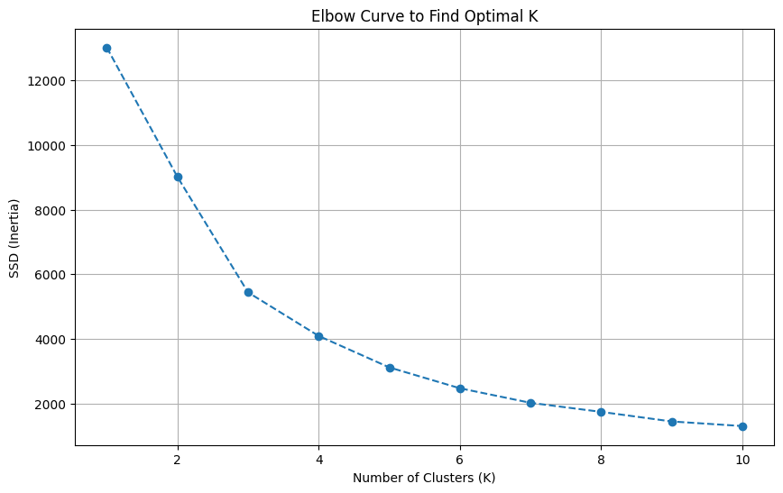
### Step 4: Fit K-Means Model
Based on the Elbow Curve, choose the optimal number of clusters (typically 3 or 4) to segment your customers.
Code:
# Choose the optimal number of clusters (e.g., K=3)
optimal_k = 3
kmeans = KMeans(n_clusters=optimal_k, max_iter=100, random_state=42, n_init=10)
k_labels = kmeans.fit_predict(rfm_scaled)

# Assign the cluster labels back to our RFM dataset
rfm['Cluster'] = k_labels

# Summary stats for each cluster
cluster_summary = rfm.groupby('Cluster').agg({
'Amount': 'mean',
'Frequency': 'mean',
'Recency': 'mean',
'CustomerID': 'count'
}).rename(columns={'CustomerID': 'Customer Count'}).reset_index()

display(cluster_summary)
 | Cluster | Amount | Frequency | Recency | Customer Count
0 | 0 | 631.424206 | 1.582255 | 246.106285 | 1082
1 | 1 | 1855.942345 | 4.672755 | 40.454180 | 3230
2 | 2 | 85904.351538 | 66.423077 | 5.038462 | 26

Experiment - 8
Apply DBSCAN clustering algorithm to find the data partitions. Use Mall_customers.csv from GitHub repository.
## DBSCAN Clustering on Mall Customers Dataset
We will load the dataset, scale the features, find appropriate DBSCAN parameters, and visualize the identified clusters.\
Code:
import pandas as pd
import numpy as np
import matplotlib.pyplot as plt
import seaborn as sns
from sklearn.preprocessing import StandardScaler
from sklearn.cluster import DBSCAN

# Load dataset
df = pd.read_csv('/content/Mall_Customers.csv')
display(df.head())
 | CustomerID | Genre | Age | Annual Income (k$) | Spending Score (1-100)
0 | 1 | Male | 19 | 15 | 39
1 | 2 | Male | 21 | 15 | 81
2 | 3 | Female | 20 | 16 | 6
3 | 4 | Female | 23 | 16 | 77
4 | 5 | Female | 31 | 17 | 40
# Select features for clustering (e.g., Annual Income and Spending Score)
features = ['Annual Income (k$)', 'Spending Score (1-100)']
X = df[features]

# Scale the features since DBSCAN is highly sensitive to distance metrics
scaler = StandardScaler()
X_scaled = scaler.fit_transform(X)

# Apply DBSCAN
# eps determines the maximum distance between two samples for one to be considered as in the neighborhood of the other.
# min_samples determines the number of samples in a neighborhood for a point to be considered as a core point.
dbscan = DBSCAN(eps=0.35, min_samples=5)
df['Cluster'] = dbscan.fit_predict(X_scaled)

# Check the cluster distributions (-1 indicates noise/outliers)
print("Cluster value counts:")
print(df['Cluster'].value_counts())
Cluster value counts:
Cluster
3 88
4 31
-1 23
5 23
0 16
1 12
2 7
Name: count, dtype: int64
# Visualize the clusters
plt.figure(figsize=(10, 6))
sns.scatterplot(
x=df['Annual Income (k$)'],
y=df['Spending Score (1-100)'],
hue=df['Cluster'],
palette='viridis',
style=df['Cluster'],
s=100
)
plt.title('DBSCAN Clustering of Mall Customers')
plt.xlabel('Annual Income (k$)')
plt.ylabel('Spending Score (1-100)')
plt.legend(title='Cluster (-1 = Outliers)')
plt.grid(True)
plt.show()
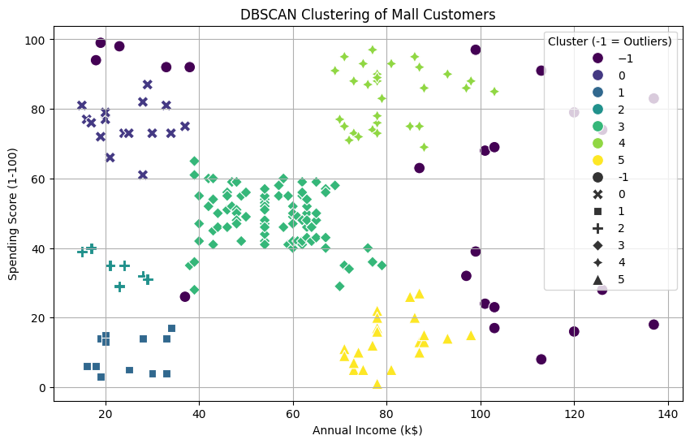

Experiment – 9
Apply PCA on IRIS.CSV. Analyze the data explainability with 2 principle components and 3 principal components
Code:
import pandas as pd
import numpy as np
from sklearn.decomposition import PCA
from sklearn.preprocessing import StandardScaler

# Load the dataset
df = pd.read_csv('/content/Iris.csv')
print("Dataset Columns:", df.columns.tolist())

# Separate features (excluding ID and species target if present)
feature_cols = [col for col in df.columns if col not in ['Id', 'Species', 'species', 'id']]

# Drop missing values to handle the ValueError
print(f"Original dataset shape: {df.shape}")
df_clean = df.dropna(subset=feature_cols)
print(f"Cleaned dataset shape: {df_clean.shape}")

X = df_clean[feature_cols]

# Standardize features
scaler = StandardScaler()
X_scaled = scaler.fit_transform(X)

# 1. PCA with 2 Components
pca_2 = PCA(n_components=2)
pca_2.fit(X_scaled)
var_2 = pca_2.explained_variance_ratio_

# 2. PCA with 3 Components
pca_3 = PCA(n_components=3)
pca_3.fit(X_scaled)
var_3 = pca_3.explained_variance_ratio_

print(f"\n--- PCA with 2 Components ---")
print(f"Explained Variance per PC: {var_2}")
print(f"Total Explained Variance (Cumulative): {sum(var_2):.4f} ({sum(var_2)*100:.2f}%)")

print(f"\n--- PCA with 3 Components ---")
print(f"Explained Variance per PC: {var_3}")
print(f"Total Explained Variance (Cumulative): {sum(var_3):.4f} ({sum(var_3)*100:.2f}%)")
Output:
Dataset Columns: ['Id', 'SepalLengthCm', 'SepalWidthCm', 'PetalLengthCm', 'PetalWidthCm', 'Species']
Original dataset shape: (150, 6)
Cleaned dataset shape: (119, 6)

--- PCA with 2 Components ---
Explained Variance per PC: [0.71834678 0.23769071]
Total Explained Variance (Cumulative): 0.9560 (95.60%)

--- PCA with 3 Components ---
Explained Variance per PC: [0.71834678 0.23769071 0.03864997]
Total Explained Variance (Cumulative): 0.9947 (99.47%)

Experiment – 10
Applying Various Normalization Techniques onto Wine Red Quality data set
1.Load the Dataset and Explore Columns
Let's first load the red wine quality dataset and inspect its structure.
Code:
import pandas as pd
# Load the dataset
df = pd.read_csv('/content/winequality-red.csv')
# Display basic information and the first few rows
print(df.info())
display(df.head())
<class 'pandas.core.frame.DataFrame'>
RangeIndex: 1599 entries, 0 to 1598
Data columns (total 12 columns):
# Column Non-Null Count Dtype
--- ------ -------------- -----
0 fixed acidity 1599 non-null float64
1 volatile acidity 1599 non-null float64
2 citric acid 1599 non-null float64
3 residual sugar 1599 non-null float64
4 chlorides 1599 non-null float64
5 free sulfur dioxide 1599 non-null float64
6 total sulfur dioxide 1599 non-null float64
7 density 1599 non-null float64
8 pH 1599 non-null float64
9 sulphates 1599 non-null float64
10 alcohol 1599 non-null float64
11 quality 1599 non-null int64
dtypes: float64(11), int64(1)
memory usage: 150.0 KB
None
 | fixed acidity | volatile acidity | citric acid | residual sugar | chlorides | free sulfur dioxide | total sulfur dioxide | density | pH | sulphates | alcohol | quality
0 | 7.4 | 0.70 | 0.00 | 1.9 | 0.076 | 11.0 | 34.0 | 0.9978 | 3.51 | 0.56 | 9.4 | 5
1 | 7.8 | 0.88 | 0.00 | 2.6 | 0.098 | 25.0 | 67.0 | 0.9968 | 3.20 | 0.68 | 9.8 | 5
2 | 7.8 | 0.76 | 0.04 | 2.3 | 0.092 | 15.0 | 54.0 | 0.9970 | 3.26 | 0.65 | 9.8 | 5
3 | 11.2 | 0.28 | 0.56 | 1.9 | 0.075 | 17.0 | 60.0 | 0.9980 | 3.16 | 0.58 | 9.8 | 6
4 | 7.4 | 0.70 | 0.00 | 1.9 | 0.076 | 11.0 | 34.0 | 0.9978 | 3.51 | 0.56 | 9.4 | 5

2. Normalization Techniques
We will apply three distinct techniques to the features (excluding the target column `quality` if present, or applying to all features):
1. **Min-Max Scaling**: Scales features to a fixed range (usually 0 to 1).
2. **Standardization (StandardScaler)**: Centers features to have a mean of 0 and a standard deviation of 1.
3. **Robust Scaling**: Scales features using statistics that are robust to outliers (IQR: Interquartile Range).
Code:
from sklearn.preprocessing import MinMaxScaler, StandardScaler, RobustScaler

# Separate features and target (assuming 'quality' is the target to predict in your ML experiment)
if 'quality' in df.columns:
X = df.drop(columns=['quality'])
y = df['quality']
else:
X = df.copy()
y = None

# 1. Min-Max Scaling
min_max_scaler = MinMaxScaler()
X_minmax = pd.DataFrame(min_max_scaler.fit_transform(X), columns=X.columns)

# 2. Standardization
std_scaler = StandardScaler()
X_std = pd.DataFrame(std_scaler.fit_transform(X), columns=X.columns)

# 3. Robust Scaling
robust_scaler = RobustScaler()
X_robust = pd.DataFrame(robust_scaler.fit_transform(X), columns=X.columns)

# Preview and compare results for a subset of features
features_to_show = list(X.columns[:3])
print("Original features (first 3 rows):")
display(X[features_to_show].head(3))

print("\nMin-Max Scaled features (first 3 rows):")
display(X_minmax[features_to_show].head(3))

print("\nStandardized features (first 3 rows):")
display(X_std[features_to_show].head(3))

print("\nRobust Scaled features (first 3 rows):")
display(X_robust[features_to_show].head(3))
Output:
Original features (first 3 rows):
 | fixed acidity | volatile acidity | citric acid
0 | 7.4 | 0.70 | 0.00
1 | 7.8 | 0.88 | 0.00
2 | 7.8 | 0.76 | 0.04
Min-Max Scaled features (first 3 rows):
 | fixed acidity | volatile acidity | citric acid
0 | 0.247788 | 0.397260 | 0.00
1 | 0.283186 | 0.520548 | 0.00
2 | 0.283186 | 0.438356 | 0.04
Standardized features (first 3 rows):
 | fixed acidity | volatile acidity | citric acid
0 | -0.528360 | 0.961877 | -1.391472
1 | -0.298547 | 1.967442 | -1.391472
2 | -0.298547 | 1.297065 | -1.186070
Robust Scaled features (first 3 rows):
 | fixed acidity | volatile acidity | citric acid
0 | -0.238095 | 0.72 | -0.787879
1 | -0.047619 | 1.44 | -0.787879
2 | -0.047619 | 0.96 | -0.666667

Experiment – 11
Applying PCA onto the Data sets.
1. Load and Preprocess the Dataset
We will load the winequality-red.csv dataset, inspect its columns, scale the features (since PCA is sensitive to data scales), and prepare it for analysis.
Code:
import pandas as pd
import numpy as np
from sklearn.preprocessing import StandardScaler
import matplotlib.pyplot as plt
import seaborn as sns

# Load dataset (using default comma separator as verified by the error output)
df = pd.read_csv('/content/winequality-red.csv')
display(df.head())
print(f"Dataset Shape: {df.shape}")
 | fixed acidity | volatile acidity | citric acid | residual sugar | chlorides | free sulfur dioxide | total sulfur dioxide | density | pH | sulphates | alcohol | quality
0 | 7.4 | 0.70 | 0.00 | 1.9 | 0.076 | 11.0 | 34.0 | 0.9978 | 3.51 | 0.56 | 9.4 | 5
1 | 7.8 | 0.88 | 0.00 | 2.6 | 0.098 | 25.0 | 67.0 | 0.9968 | 3.20 | 0.68 | 9.8 | 5
2 | 7.8 | 0.76 | 0.04 | 2.3 | 0.092 | 15.0 | 54.0 | 0.9970 | 3.26 | 0.65 | 9.8 | 5
3 | 11.2 | 0.28 | 0.56 | 1.9 | 0.075 | 17.0 | 60.0 | 0.9980 | 3.16 | 0.58 | 9.8 | 6
4 | 7.4 | 0.70 | 0.00 | 1.9 | 0.076 | 11.0 | 34.0 | 0.9978 | 3.51 | 0.56 | 9.4 | 5
Dataset Shape: (1599, 12)
2. Standardize Features and Apply PCA
PCA is highly sensitive to the scale of the features. We will scale the features to have a mean of 0 and variance of 1, then apply PCA to project the data.
from sklearn.decomposition import PCA

# Strip any accidental whitespace from column names
df.columns = df.columns.str.strip()

# Separate features and target
X = df.drop(columns=['quality'])
y = df['quality']

# Standardize the features
scaler = StandardScaler()
X_scaled = scaler.fit_transform(X)

# Fit PCA
pca = PCA()
X_pca = pca.fit_transform(X_scaled)

# Calculate Cumulative Explained Variance
cumulative_variance = np.cumsum(pca.explained_variance_ratio_)

# Plot Explained Variance
plt.figure(figsize=(8, 5))
plt.bar(range(1, len(pca.explained_variance_ratio_) + 1), pca.explained_variance_ratio_, alpha=0.6, align='center', label='Individual explained variance')
plt.step(range(1, len(cumulative_variance) + 1), cumulative_variance, where='mid', label='Cumulative explained variance', color='red')
plt.ylabel('Explained variance ratio')
plt.xlabel('Principal components')
plt.title('Explained Variance Ratio by Principal Components')
plt.xticks(range(1, len(pca.explained_variance_ratio_) + 1))
plt.legend(loc='best')
plt.grid(True, linestyle='--', alpha=0.5)
plt.tight_layout()
plt.show()
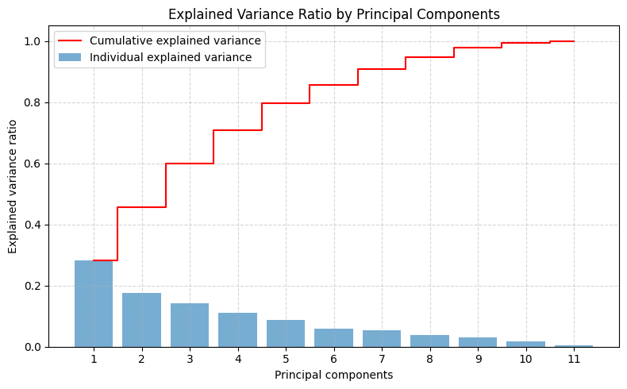
3. Visualize 2D Projection
Let's project the dataset onto the first two principal components and visualize the distribution, coloring the points by wine quality.
Code:
pca_2d = PCA(n_components=2)
X_pca_2d = pca_2d.fit_transform(X_scaled)

plt.figure(figsize=(10, 7))
scatter = plt.scatter(X_pca_2d[:, 0], X_pca_2d[:, 1], c=y, cmap='viridis', alpha=0.8, edgecolor='none')
plt.colorbar(scatter, label='Wine Quality')
plt.xlabel('First Principal Component (PC1)')
plt.ylabel('Second Principal Component (PC2)')
plt.title('PCA 2D Projection of Red Wine Quality Dataset')
plt.grid(True, linestyle='--', alpha=0.5)
plt.show()

# Print loading scores for PC1 and PC2
loadings = pd.DataFrame(
pca_2d.components_.T,
columns=['PC1', 'PC2'],
index=X.columns
)
print("=== Feature Loadings for PC1 and PC2 ===")
display(loadings)
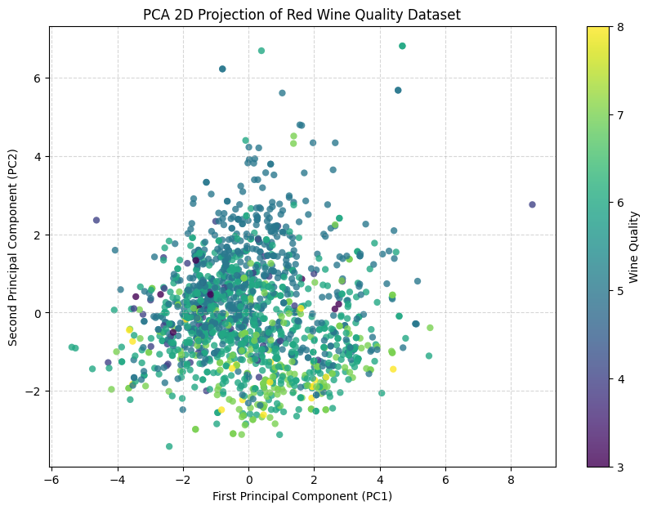
=== Feature Loadings for PC1 and PC2 ===
 | PC1 | PC2
fixed acidity | 0.489314 | -0.110503
volatile acidity | -0.238584 | 0.274930
citric acid | 0.463632 | -0.151791
residual sugar | 0.146107 | 0.272080
chlorides | 0.212247 | 0.148052
free sulfur dioxide | -0.036158 | 0.513567
total sulfur dioxide | 0.023575 | 0.569487
density | 0.395353 | 0.233575
pH | -0.438520 | 0.006711
sulphates | 0.242921 | -0.037554
alcohol | -0.113232 | -0.386181

